Task 1
GPT prompt:
Act as a senior full-stack architect. I'm building a personal portfolio website with a Contact Us system for a MERN-stack internship task. Stack: Next.js App Router, Supabase (DB + Auth), Prisma, Resend for email, Google reCAPTCHA v3, deployed on Vercel. Give me: (1) a page/section list for the portfolio (Hero, About, Skills, Projects, Experience/Education, Contact, Footer), (2) the database flow from form submit → Prisma → Supabase → Resend email, (3) the authentication flow for a single seeded Admin user logging into a protected dashboard, (4) a deployment plan (repo → env vars → Vercel → production branch). Format as a short structured plan I can paste into a doc.
Result:
https://chatgpt.com/share/6a57996b-d138-83ee-9848-786743e2cd53
GPT prompt:
Based on the plan above, describe a clean, modern portfolio design concept — color palette, typography style, layout for Hero and Projects sections. Then generate a single reference image showing the overall portfolio layout (Hero + Projects section) in this style.
Result:
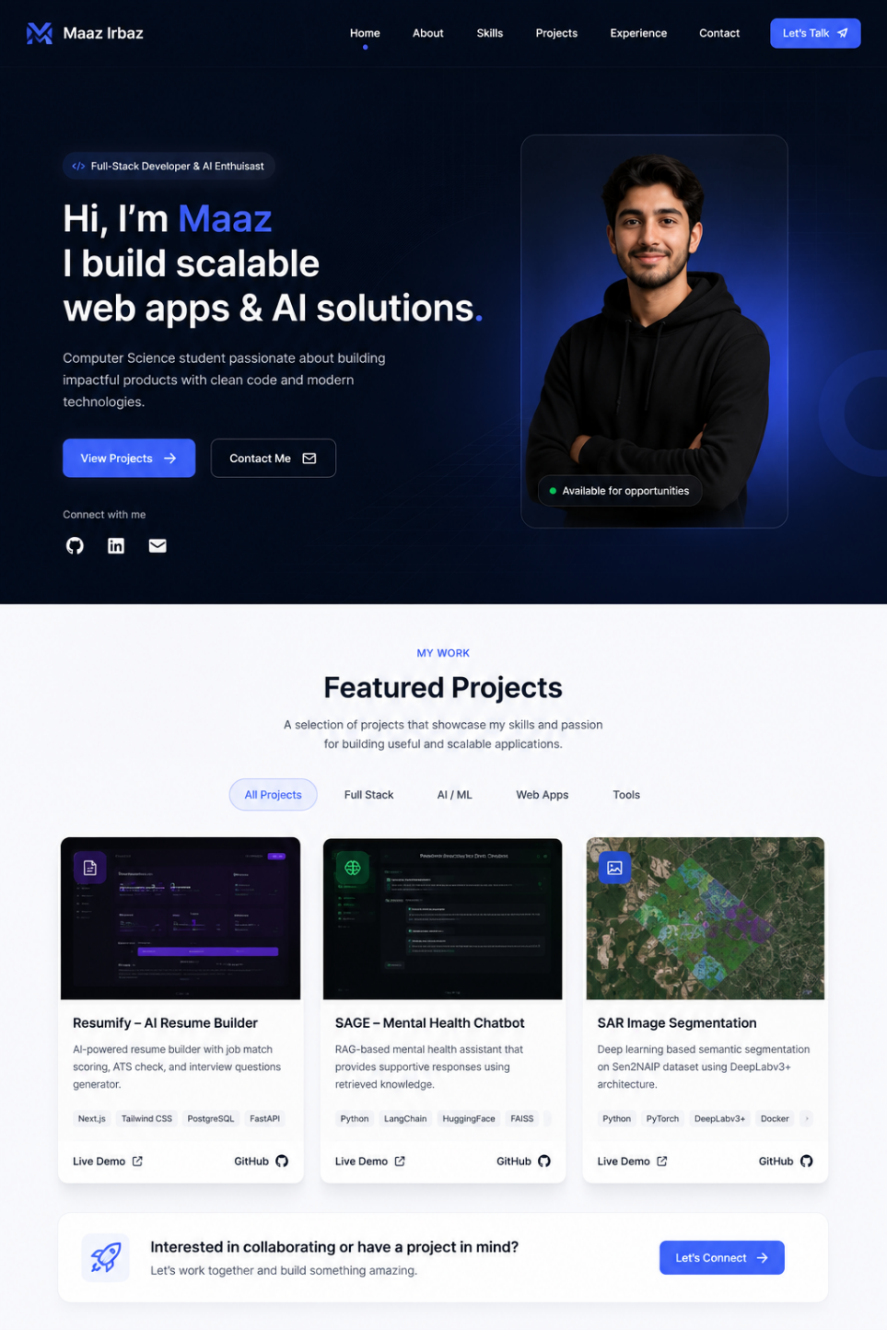

Task 2
Cursor Prompt:
Scaffold a Next.js (App Router, TypeScript, Tailwind, shadcn/ui) project for a personal portfolio. Create sections/components: Hero, About, Skills, Projects, Experience, Contact, Footer. Make it fully responsive and accessible. Use placeholder content for now.
Cursor Prompt:
Add a Contact Us section with a form containing name, email, phone/subject, and message fields. Add client-side validation (required fields, valid email format, min message length) with inline, user-friendly error messages. Don't wire it to a backend yet just local state and a console.log on submit.
Task 3
deployed
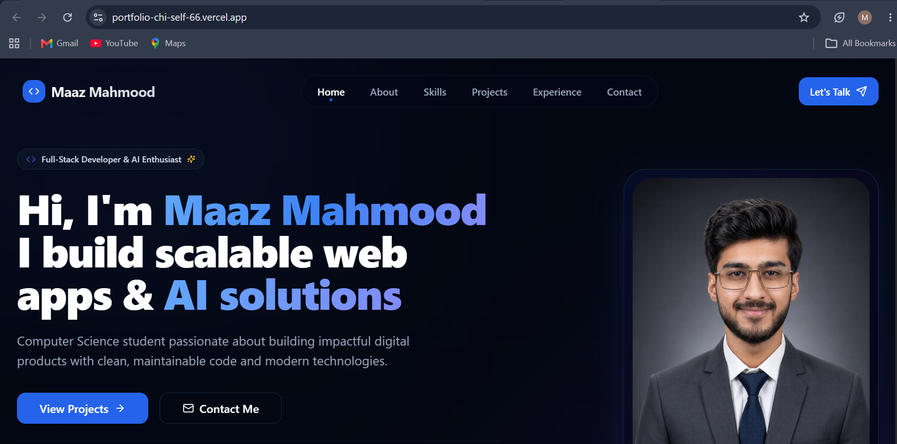
Task 4
GPT prompt:
Design a Prisma schema for a Contact model with fields: id, name, email, phone (nullable), subject (nullable), message, status (enum: Pending, Done, Completed, Resolved — default Pending), created_at, updated_at. Also design a Profile model linked to Supabase Auth (auth_user_id, name, email, role). Output valid Prisma schema syntax.

Cursor prompt:
Set up Prisma in this Next.js project connected to Supabase Postgres. Add this schema: schema in docs. Generate the migration, run prisma generate, and create a server action submitContact that validates and inserts a row into Contact with status "Pending". Wire the Contact form's onSubmit to this server action, with loading/success/error UI states.
Task 5
Cursor prompt:
Integrate the Resend SDK. After a Contact row is successfully inserted, send an email to my admin email using Resend with subject "New Contact Query" and body including the sender's name, email, and a short summary of the message. Wrap the Resend call in try/catch so a failed email never blocks the form submission. show the same success UI to the user either way, but log the error server-side.
Task 6:
GPT prompt:
Explain the correct approach to seed exactly one Admin user in Supabase: creating the user in Supabase Auth via the admin API, then inserting a matching row in the Profile table with role "Admin", using a Node/TS script. Outline the script's steps before I generate the code.
Cursor prompt:
Read the structure and Create scripts/seed-admin.ts that uses the Supabase service role key to create one Admin user in Supabase Auth (email + password from env vars) and inserts a linked row into the Profile table with role "Admin". Add an npm script seed:admin to run it with ts-node.
Cursor prompt:

